**Final Assignment 13 – Mohammed Abdin**

**Submission Instructions:**

Your submission for this assignment should be a Word document that includes the following screenshots, each labeled for the step that the screenshot represents:

**Part 1**

1. Provide a screenshot of the “Assignment13” folder in VS Code to show that you added a file called my_sql_container.py and wrote the code to run a MySQL *container* named final_mysql_container in port 5600.

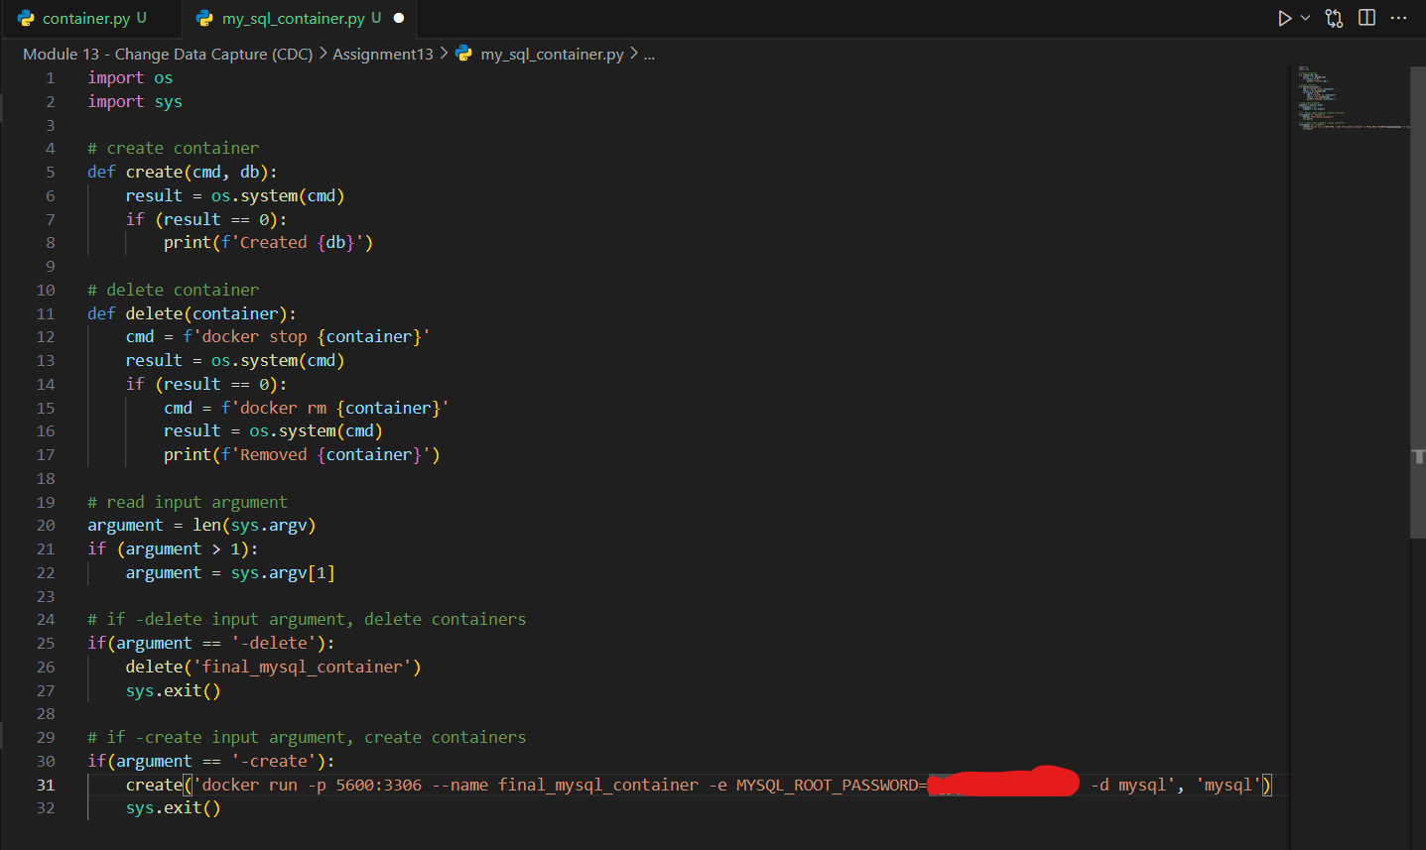

1. Provide two screenshots to show that you ran the my_sql_container.py file using the create parameter to create a Docker *container*: one screenshot of your Terminal window and one screenshot of your Docker application to show that the *container* has been created.

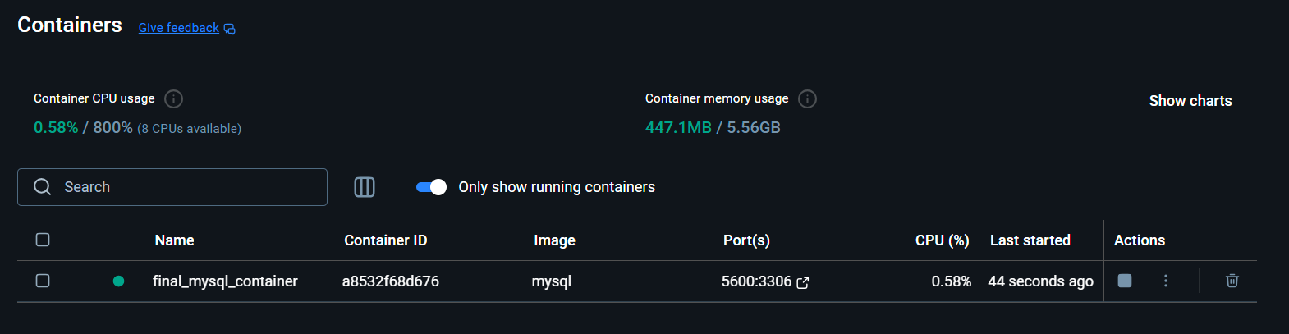

1. Provide a screenshot to show that you created another file called my_mongo_container.py and wrote the code to run a MongoDB *container* named final_mongo_container in port 1800.

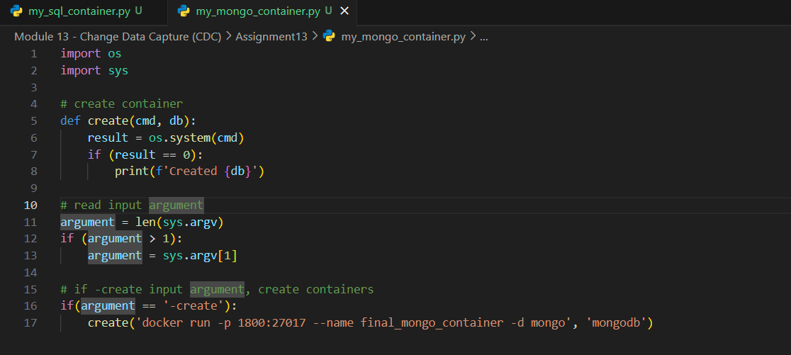

1. Provide two screenshots to show that you ran the my_mongo_container.py file using the create parameter to create a Docker *container*: one screenshot of your Terminal window and one screenshot of your Docker application to show that the *container* has been created.

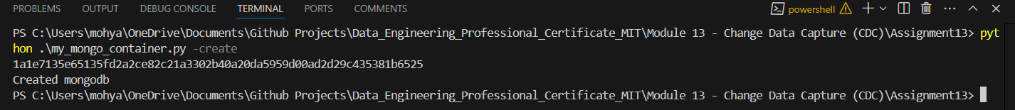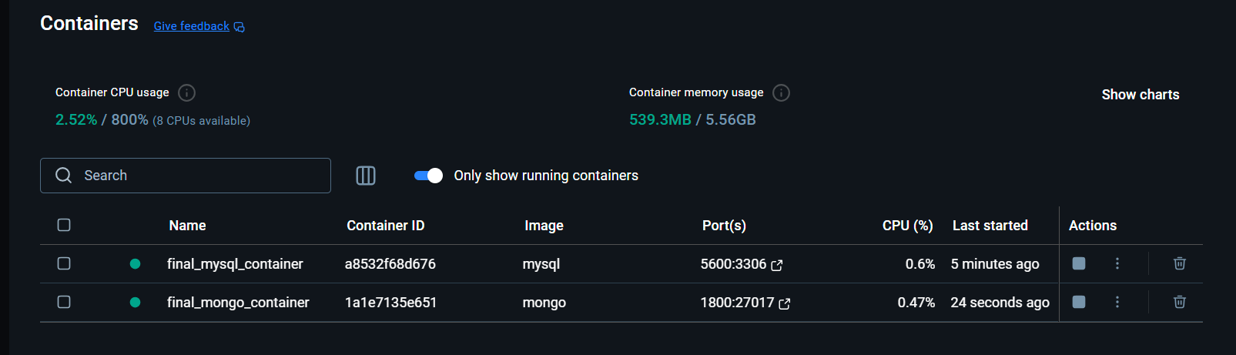

1. Provide a screenshot to show that you created another file called my_redis_container.py and wrote the code to run a Redis *container* named final_redis_container using port 2400.

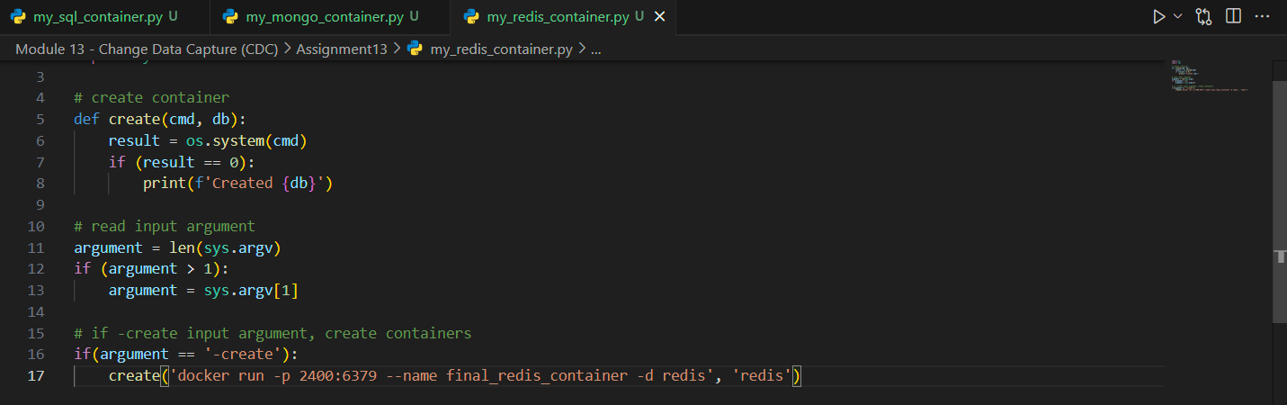

1. Provide two screenshots to show that you ran the my_redis_container.py file using the create parameter to create a Docker *container*: one screenshot of your Terminal window and one screenshot of your Docker application to show that the *container* has been created.

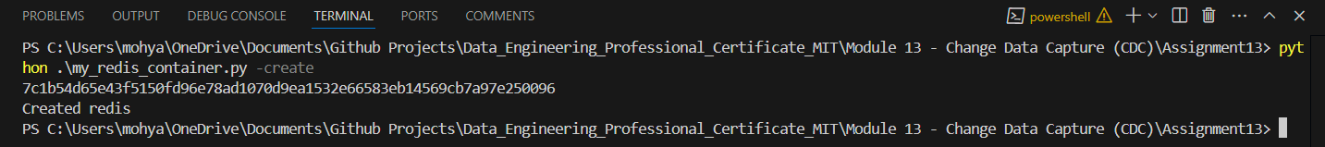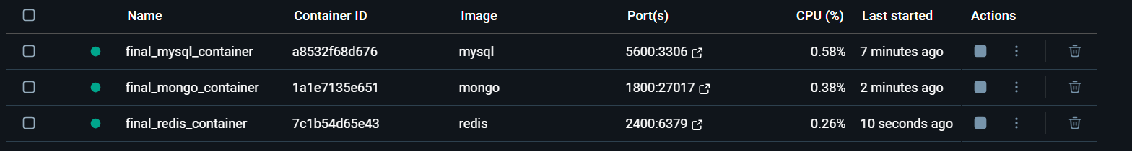

1. Provide a screenshot to show that you created another file called my_cassandra_container.py and wrote the code to run a Cassandra *container* named final_cassandra_container using port 1000.

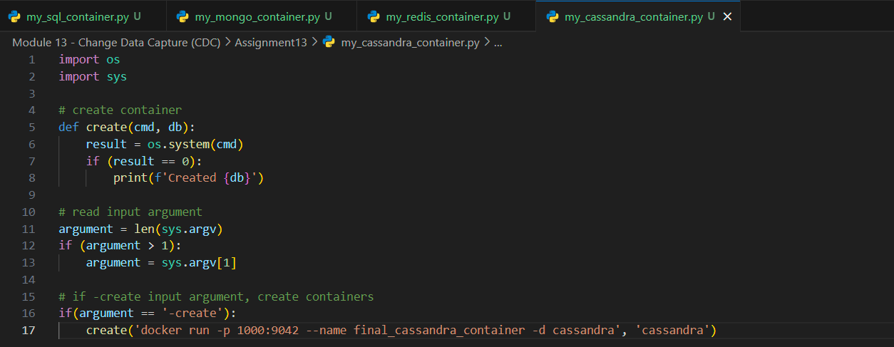

1. Provide two screenshots to show that you ran the my_cassandra_container.py file using the create parameter to create a Docker *container*: one screenshot of your Terminal window and one screenshot of your Docker application to show that the *container* has been created.

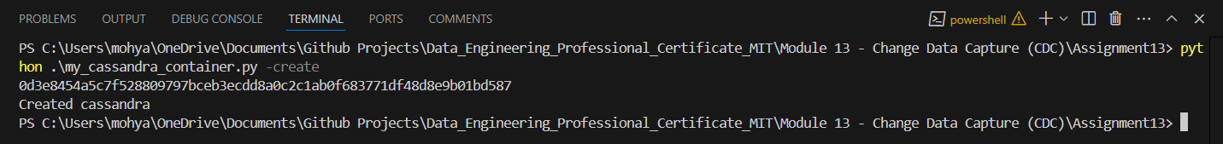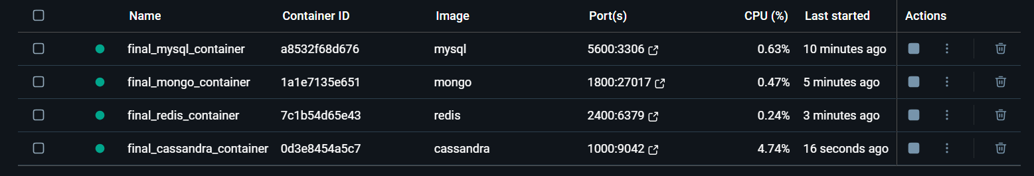

1. Provide a screenshot that shows that all the Docker *containers* have been eliminated.

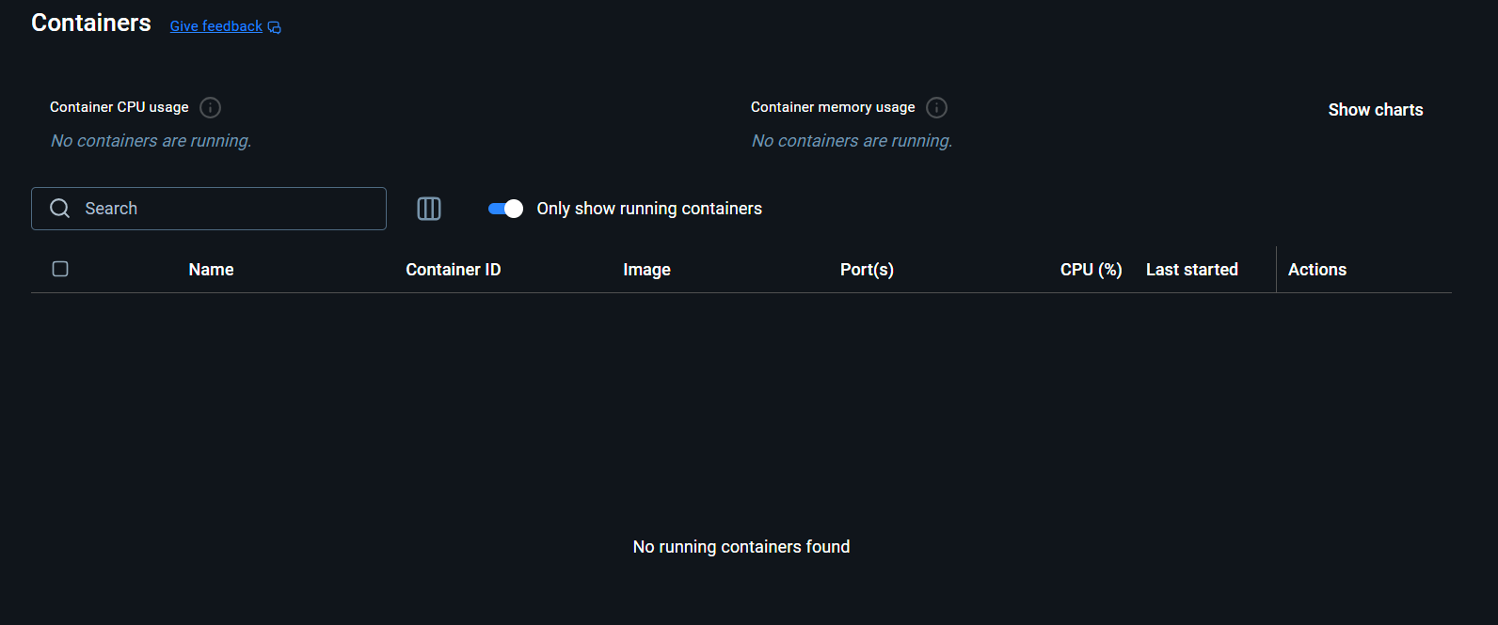

**Part 2**

1. Provide a screenshot to show that you successfully created the container.py file and that it creates all the *containers* defined above using the same parameters as in Part 1.

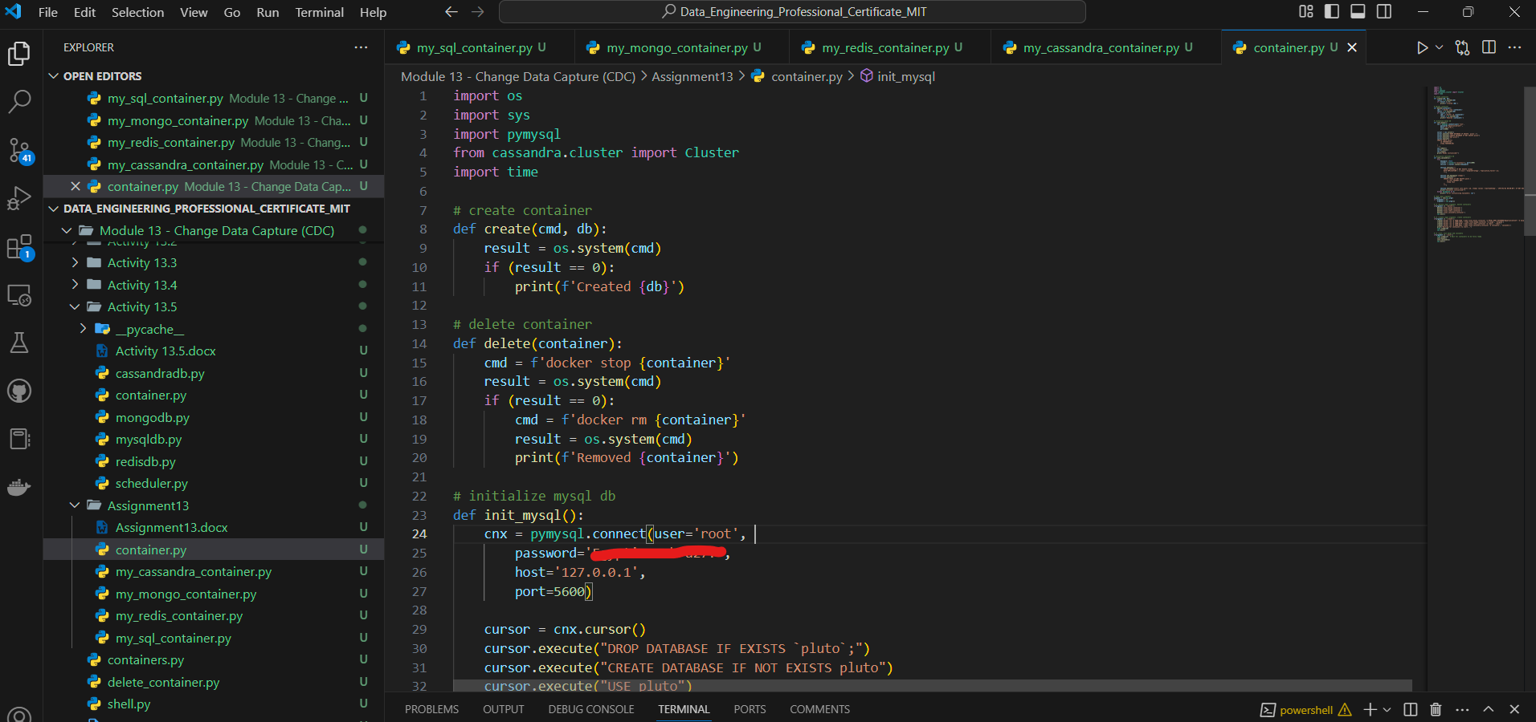

1. Provide a screenshot running the container.py file in Docker to show that all the *containers* have been created successfully.

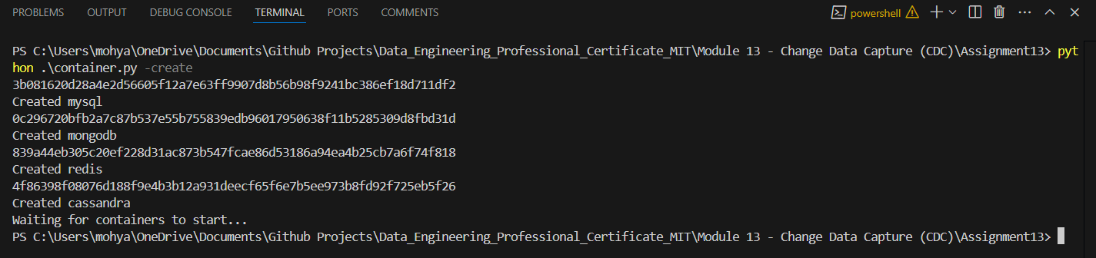

1. Provide a screenshot to show that the mysqldb.py file has been created in the “Assignment13” folder.

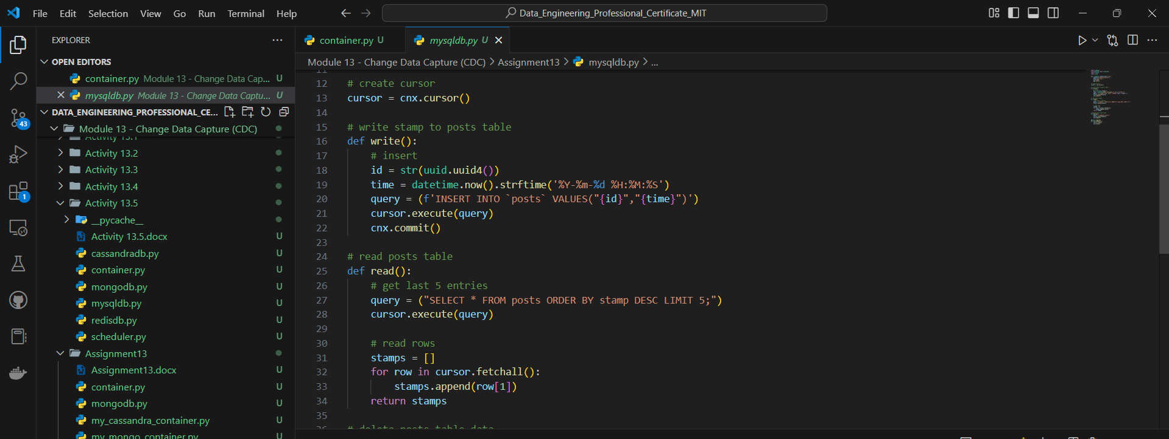

1. Provide a screenshot of your Terminal window showing that the mysqldb.py file has run successfully.



1. Provide a screenshot to show that the mongodb.py file has been created in the “Assignment13” folder.

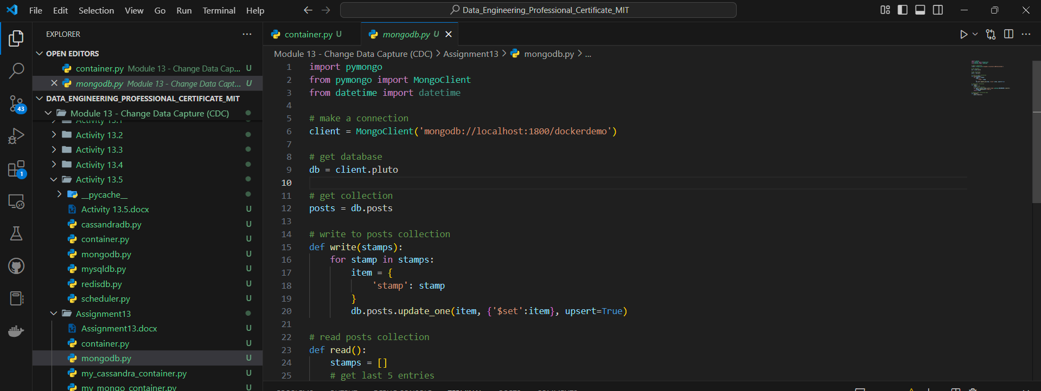

1. Provide a screenshot of your Terminal window showing that the mongodb.py file has run successfully.



1. Provide a screenshot to show that the scheduler.py file has been created.

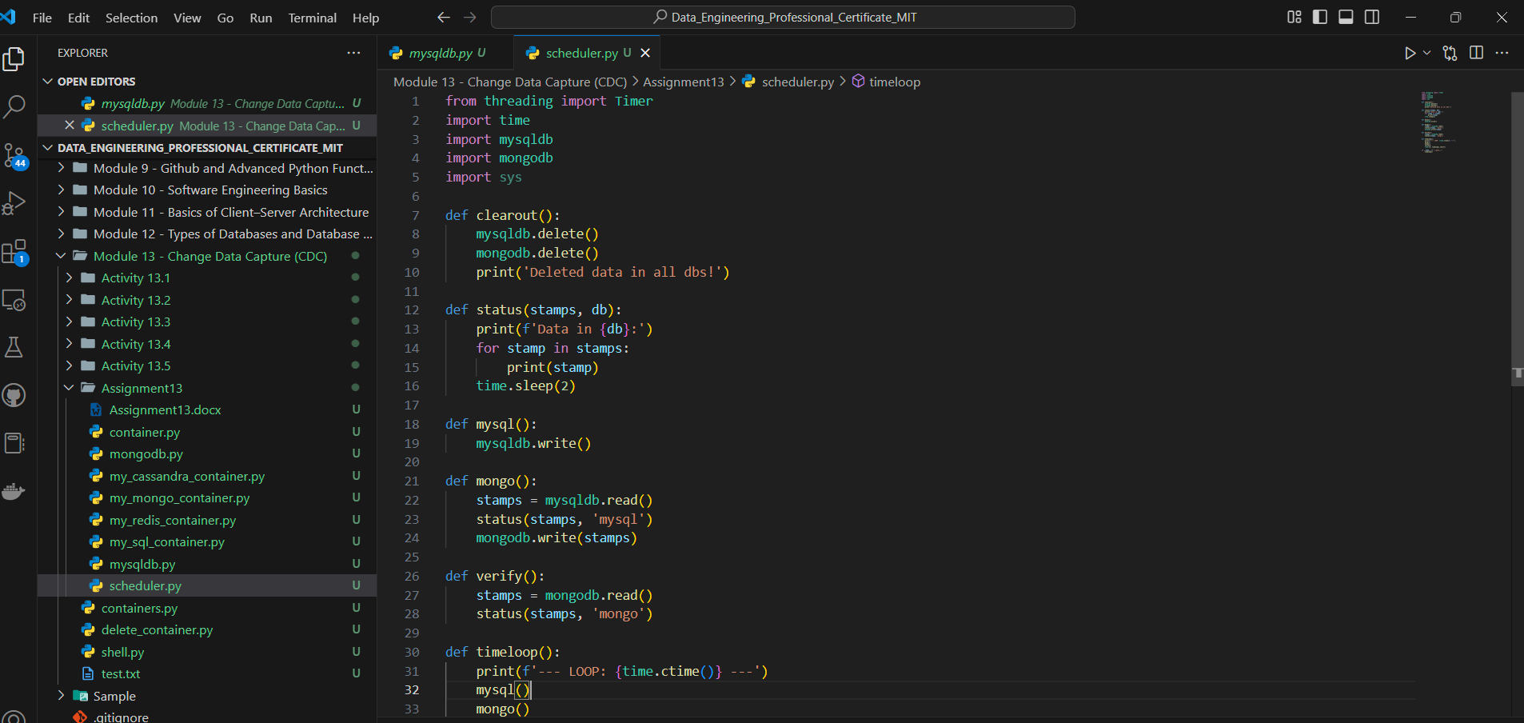

1. Provide a screenshot of the command prompt showing that you successfully ran the container.py Python program from the command prompt passing -init as a parameter.



1. Provide a screenshot of your Terminal window showing the scheduler.py program running.

